Game Design Document

Fill up the following document

1. Write the title of your project.

Mission to save Earth

1. What is the goal of the game?

The goal of the game is to enhance the shooting skills of the player & to encourage the player to save Earth.

1. Write a brief story of your game.

There is a fighter named Sam in a space shuttle who is stopping the asteroids

from falling on the Earth. He is doing so to protect his home planet.

The space shuttle contains weapons like lasers to destroy asteroids.

1. Which are the playing characters of this game?

* Playing characters are the ones who respond to the user based on the input from the user.
* Cars, monkeys, dinos, wizards, etc., are the playing characters in the game.

|  |  |  |
| --- | --- | --- |
| Number | Character Name | What can this character do? |
| 1 | Sam | It shoots the asteroids and can controlles by the user |
| 2 |  |  |
| 3 |  |  |
| 4 |  |  |
| 5 |  |  |
| 6 |  |  |
| 7 |  |  |
| 8 |  |  |

1. Which are the Non-Playing Characters of this game?

* Non-Playing characters are the ones that don't have an action or behavior when the user interacts with the game.
* Hurdles, stones, bananas, coins, etc., are non-playing characters in the game.

|  |  |  |
| --- | --- | --- |
| Number | Character Name | What can this character do? |
| 1 | Earth | It is the character that needs to be protected from the asteroids. |
| 2 | Asteroids | These are the obstacles that need to be destroyed. |
| 3 |  |  |
| 4 |  |  |
| 5 |  |  |
| 6 |  |  |
| 7 |  |  |
| 8 |  |  |

Draw your imagination of this game. What does this game look like?

* Draw the game either on your computer or on paper.
* Add images of the game scenes to show each of the playing and non-playing characters at least once.

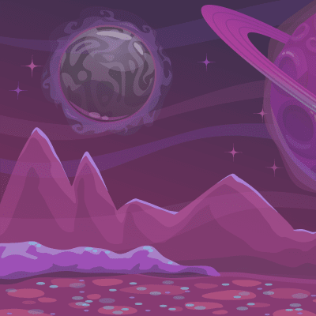

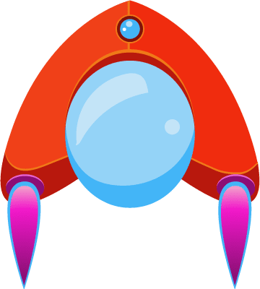

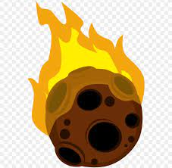

How do you plan to make your game engaging?

I will make the game as a shooting game and add obstacles

controls will be easy to be used by the player.